NEWSLETTER
December 2020
Ho Ho Ho
NELSON DISTRICTS WOODTURNING CLUB

El Presidente
Hi all,
hope you are all doing well, it was great to see so many turn out for the Xmas do, many thanks to those for organising the function.

The demo for Tuesday is hopefully a couple of videos to watch from You Tube, that could possibly inspire us to do something the same or the equivalent. Speaking of, for the demo table could you bring your normal show and tell and could you also bring along something turned with a Xmas theme, there will be a prize on the night for best one selected, as we do with the people’s choice.

Niki Marshall has invited the club along to her shed on the 31st January @ 1pm. I’m sure this will be an interesting afternoon for all those that go along and will give inspiration to all. Dave has also mentioned that he will be having an afternoon to go and check out his shed in late February and I will have my shed open for an afternoon later on in March possibly to also check out Bryan’s shed the same afternoon - watch this space.

As you are all aware, there is no demo meeting in January as most are away but as mentioned previously there will be a turning day hosted by Simon. Date to be given to all at the demo and again sent out in email.

Many thanks must go to pinnacle paints for their kind donation of 40 litres of white paint for the refurbishment of the clubrooms.

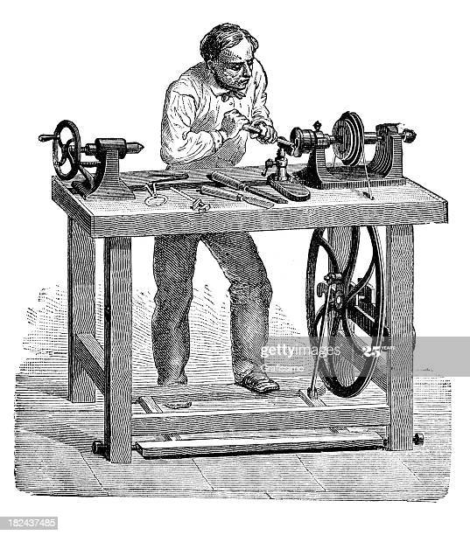

This is about it from me except to say I wish you all a very Merry Xmas and a wonderful
New Year ahead - it can only get better.

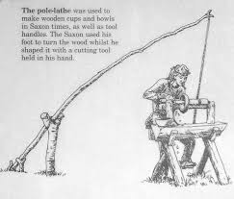
Hello Team from your new Treasurer

Its Subs time again.

Subs are the same as last year $60 for the year.

If you are able then deposit the funds by electronic banking. The club account is below. Add your name to the particulars section.

Westpack Nelson. 030 703 0395627 00

If you are unable to do that then bring to the next club night.

If you’ve already paid send me a reply by email.
rogerwendybee@gmail.com

Thanks

Cheers

Roger Bee
Treasurer
Nelson Woodturning Club

For a free quote, call us today on 03 539 1453 or 027 235 9246

WOOD
There is plenty of wood for turning inside and outside of the club rooms if you do take some then a small donation to the club would be appreciated as time is spent by other club members in getting it cut to size.

FACEBOOK - https://www.facebook.com/nelsonwoodturning/
WHATS ON THIS MONTH
Tuesday 8th Dec Meeting & Demo 7.00pm
Monday Evening Terry's night 6.30-9.00pm
Tuesday Evening Tuesday Turning 6.30 – 9.30pm
Thursday Morning Morning Turning 9.00-11.00am
Thursday 4th Feb Committee meeting 7.00
Tuesday 9th Feb General meeting 7pm

DEMO – videos to watch from You Tube

If there is something you would like to see in the newsletter let me know or email me painedave@hotmail.com

Club Officers

PRESIDENT Stuart Croft Ph 0212015158
Vice President Simon Martin Ph 0211503032
Treasurer Roger Bee Ph 5488413
Temp Secretary Terry Brunel Ph 5480885
Editor David Paine Ph 0275732988
email painedave@hotmail.com

FACEBOOK - https://www.facebook.com/nelsonwoodturning/ Check it out.
You don’ need to be on Facebook to see the page, just click on the link in BLUE

